Homework 1
Damiche Inès
Exercice 1
My github: damicheines-cyber
I reviewed mehdi147899 and pasdideepourunnom for example.
Press the "Check MetaMask Balance" button with your Metamask connected. How much Wei does it say you have and is this correct? Give a short reason for your belief. (1 point):

The website shows a balance of 265382347469241920 Wei, which corresponds to approximately 0.265 ETH after converting Wei to ETH. This matches my MetaMask balance on the Sepolia network. It worked because the website has access to my MetaMask account, so it knows my public address.

Exercice 2
Part A
Next, briefly understand how Github uses RSA and SSH to verify the identity of your local computer. You will notice that there is a difference in how public and private keys are used. Briefly explain the difference and under which circumstance each method is appropriate. (1 point):
In GitHub, SSH with RSA keys is used for authentication and verifying someone’s identity. The private key stays on the user’s computer and is used to sign a challenge, while GitHub uses the public key to verify it.
RSA keys can also be used for encryption, where the public key is used to encrypt data and the private key is used to decrypt it. The difference is that encryption is used for confidentiality, whereas GitHub uses RSA keys for authentication and confirming someone’s identity.

Bibliography :
Github documentation - https://docs.github.com/en/authentication/connecting-to-github-with-ssh/about-ssh?

Part B
I tried with the same input as in the assignment instructions (11000100001011110101100101111100) and it worked.
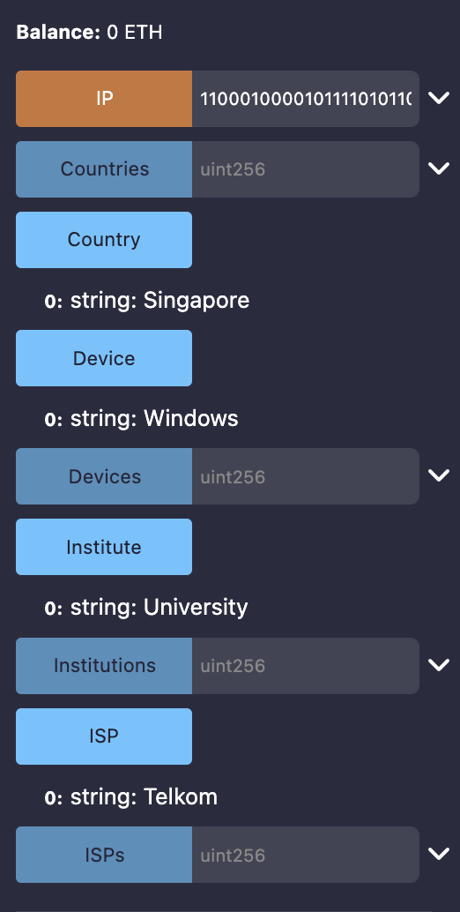
Then I tried to change the country and it worked :
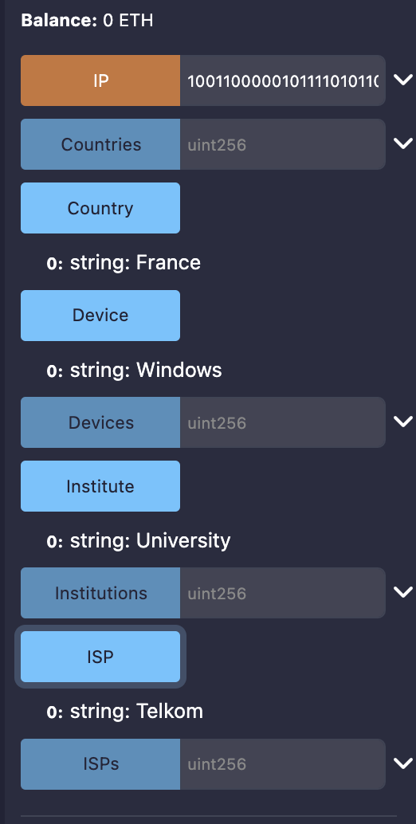
Exercice 3
During the class simulation, the blockchain network was represented by students, where each student acted as a node in the system. All nodes had a validation role, but not all of them behaved in the same way. Some students were designated as proposers, meaning they were responsible for starting the propagation of a message, while others acted as attestors, whose role was to pass on the message. This setup was very helpful to understand how real blockchain networks rely on different but complementary roles.
Not all peers were honest and reliable during the simulation. At the beginning of the game, I received a card saying “be honest,” which made me assume that other students may have received cards instructing them to behave maliciously. Based on this, I paid attention to how messages evolved across rounds. In one round, I was the proposer, so I knew exactly what the original message was. After passing it to another student, I noticed that the message was modified. Later, when messages came back to me, most of them were identical, but one or two were clearly different, and often came from the same people. This showed the presence of malicious nodes, which is a clear example of Byzantine faults. However, not all modifications were intentional. Some message changes were accidental, for example due to bad handwriting or misunderstanding, which also affected the transmission of the message.
The simulation also allowed us to experiment with different network topologies. In the first round, the network followed a linear topology. The message was passed along a line, with only one copy and only four people involved. This configuration is very fragile. If one node is slow, inattentive, or malicious, the message can be lost or modified, and there is no way to recover it.
In later rounds, the topology changed to a mesh structure. Multiple copies of the message were distributed to many participants, meaning that each node could receive the same message from different nodes. This made the network more robust, as the proposer could compare different versions and choose the one that appeared most often. This process was similar to how real blockchains rely on redundancy and majority agreement. However, this robustness came at a cost: students had to manage more messages and more interactions, which increased the workload. This reflected the real-world trade-off between security and communication costs in distributed networks.

Several consensus mechanisms were also tested. In the first rounds, the system resembled a simple Proof of Work mechanism. The first person to give the correct answer earned the right to broadcast the message and received a reward. This created competition and rewarded speed, similar to how miners compete in PoW blockchains. In an other round, we were divided in teams and were allowed to discuss the message before answering. If the answer and message were correct, the bridge of the winning team decided whether to keep all the points or share them with the team. This introduced coordination, trust, and governance choices.
Another mechanism relied on majority voting. One proposer was selected to announce the message, and the other students voted on whether it was correct. If the majority approved, the proposer received the reward, even if the message was objectively wrong. This showed that consensus depends on agreement rather than absolute truth. Finally, Proof of Stake mechanisms were simulated. Proposers had to stake points, gaining more if correct and losing points if wrong. Pool staking was also tested, where a group shared both rewards and losses.
One important difference with real blockchains is that we were not anonymous. Because identities were known, social dynamics could influence outcomes, and some participants could be advantaged or disadvantaged in ways that would be less visible in real blockchain systems that rely more on pseudonymity.
Overall, several key parameters clearly affected performance and consensus efficiency. Network topology and message redundancy strongly influenced robustness. Propagation speed and message complexity affected accuracy. Incentive design shaped behavior, especially when penalties were introduced. Governance and reward distribution influenced cooperation. The simulation also clearly illustrated the Blockchain trilemma: speed and security were easier to achieve with central control (the Professor).
If I were advising a blockchain protocol, I would ask: How decentralized does the system need to be versus how fast it needs to operate ? How much message redundancy is acceptable before communication costs become too high ? How fast must consensus be reached ? How complex is the data being shared ? Do proposers have enough at stake to behave honestly ? And how should rewards be distributed to balance fairness, cooperation, and performance ? These questions directly reflect what I observed during the game and highlight how small design choices can have large effects on blockchain performance.

